

**WEB APPLICATION DEVELOPMENT**

**CSC318**

**PORTFOLIO WEBPAGE**

**FACULTY OF COMPUTER SCIENCE AND MATHEMATICS**

**DIPLOMA IN COMPUTER SCIENCE**

**JCS1105F**

**PREPARED BY**

**MUHAMMAD ARIEF NAZARUDDIN BIN ISMAIL**

**UiTM ID NO: 2018412994**

**PREPARED FOR**

**Ts. DR. RASHIDAH MOKHTAR**

**SUBMISSION DATE**

**27th NOV 2020**

**Assessment’s Rubric**

Your webpage should meet the requirements in the following assessment’s rubric:

**Individual Assessment’s Rubric**

|  |  |  |  |
| --- | --- | --- | --- |
| Student Name: | MUHAMMAD ARIEF NAZARUDDIN BIN ISMAIL | | |
| Matric Number: | **2018412994** | | |
| Project Title: | **PORTFOLIO WEBPAGE** | | |
| Class/Group: | **JCS1105F** | **Submission Date:** |  |

**Criteria A: CLO2 – Build web pages using mark-up language for efficient user interaction (7%)**

|  |  |  |  |  |  |  |
| --- | --- | --- | --- | --- | --- | --- |
| Score  Criteria | | | *None*  *0 point* | *Poor*  *1 point* | *Fair*  *2 points* | *Good*  *3 points* |
| Overall Interface / Concept | | | *Incomplete website* | *Presented with less than 50% meet the requirements* | *Presented with 70% meet the requirements* | *Well-presented and clearly meet the requirements* |
| HTML | **Number of pages** | | *Not exist in the product* | *<=3 pages* | *<=4 pages* | *>= 5 pages* |
| **Media** | image | *Not exist in the product* | *Criteria exists but doesn’t works correctly.* | *Criteria exists 70% in product and works correctly in all areas.* | *Criteria exists in product and works well in all areas* |
| video | *Not exist in the product* | *Criteria exists but doesn’t works correctly* | *Criteria exists 70% in product and works correctly in all areas.* | *Criteria exists in product and works well in all areas* |
| audio | *Not exist in the product* | *Criteria exists but doesn’t works correctly* | *Criteria exists 70% in product and works correctly in all areas.* | *Criteria exists in product and works well in all areas* |
| **link(s)** | Within same page | *Not exist in the product* | *Criteria exists but doesn’t works correctly* | *Criteria exists 70% in product and works correctly in all areas.* | *Criteria exists in product and works well in all areas* |
| Within website | *Not exist in the product* | *Criteria exists but doesn’t works correctly* | *Criteria exists 70% in product and works correctly in all areas.* | *Criteria exists in product and works well in all areas* |
| External website | *Not exist in the product* | *Criteria exists but doesn’t works correctly* | *Criteria exists 70% in product and works correctly in all areas.* | *Criteria exists in product and works well in all areas* |
| Open local file | *Not exist in the product* | *Criteria exists but doesn’t works correctly* | *Criteria exists 70% in product and works correctly in all areas.* | *Criteria exists in product and works well in all areas* |
| **table(s)** | With border | *Not exist in the product* | *Criteria exists less than 50% in product and doesn’t works correctly.* | *Criteria exists 70% in product and works correctly in all areas.* | *Criteria exists in product and works well in all areas* |
| Merging cells | *Not exist in the product* | *Criteria exists but doesn’t works correctly* | *Criteria exists 70% in product and works correctly in all areas.* | *Criteria exists in product and works well in all areas* |
| **Form** | Include 5 elements | *Not exist in the product* | *Criteria exists less than 50% in product and doesn’t works correctly.* | *Criteria exists 70% in product and works correctly in all areas.* | *Criteria exists in product and works well in all areas* |

**Criteria B: CLO3 – Setting hosting domain (8%)**

|  |  |  |  |  |
| --- | --- | --- | --- | --- |
| Score  Criteria | *None*  *0 point* | *Poor*  *1 point* | *Fair*  *3 points* | *Good*  *5 points* |
| Configuration & Published Online | *Not exist in the product* | *Hosting account created however not properly configured and not published.* | *Properly configured, but not successfully published* | *Successfully published at Online (via Hosting Site)* |
| Navigations and Flows | *No navigation and the flow of the web content is not existing* | *More than 2 links not working* | *Almost all navigations (links) working. Only <=2 links not working.* | *All navigations and flows are working correctly* |
| Content Structure | *Content structure is not presented in a clear manner* | *Content structure is 70% confusing and difficult to follow* | *Content structure is 30% confusing and difficult to follow* | *Content is presented in a clear manner*  *that is easy to follow.* |
| Critical Thinking &  Problem Solving | *The entire problem / case study not been solved.* | *Less of 50% of the problem / case study solved and not all criteria fulfilled.* | *70% of the problem / case study solved and not all the criteria fulfilled.* | *The problem /case study solved and all the criteria fulfilled.* |
| Report | *Incomplete report* | *Presented with less than 50% meet the requirements* | *Presented with 70% meet the requirements* | *Well presented and clearly meet the requirements* |

***OVERALL SCORE:***

|  |  |  |  |  |  |
| --- | --- | --- | --- | --- | --- |
| *Total*  *Criteria A:*  *36 points*  *(7%)* | *points*    *%* | *Total*  *Criteria B:*  *25 points*  *(8%)* | *points*  *%* | *Total Percentage:*  *(15%)* |  |

Evaluated by: Date:

INTRODUCTION

DESCRIPTION

This webpage about my portfolio that anything related to me. There are total 5 pages in this webpage. Firstly, in the first page visitor can find my photos and some of my opening words that contains details what is I am currently doing at this time and where am I studying. It also contains planets that are represent other page and I use the galaxy scenery as background of this page. Next, the second page is when visitor click the About Me planet that contains the specific details about me or my biodata, also the brief description is my information that described a little bit about me in form of paragraph and also contained pictures of my school and University. The biodata also contains external link that will proceed to my social media. The next page is page about My Obsession which is I divided into 3 obsessions and elaborate each one of it briefly, this page contains audio in the end of the page. Visitor also can learn the details about my skill in this page instead of the skill I mention in About Me page. The second last page is page about my goals and ambition, in this page visitor can learn personality of me and the achievement that I achieve in school. Also, visitor can imagine what I will be in the future after I complete my studies. The last page is feedback form to ask visitor about the experience spend time checking my E-portfolio website because I will evaluate the answer from every visitor to improve my webpage. In this last page also contain request form about my skill to repair and upgrade laptop in case there has visitor want me to diagnose their laptop or PC. All the pages excluding introduction page is the environment of the planet after clicked the pages in introduction page.

OBJECTIVE

* To share my experience to the visitor
* To expose myself to other people
* To inspire people about my life
* To share knowledge to visitor
* To build my skill creating website
* To make people recognize myself
* To get acknowledgement by visitor

Design or Element

1. Table

* To divide the page into 2
* To divide my contents in the webpage
* A nested table element to fill up the contents
* A border to separated contents
* Merging a table to fill some content that has list more than one
* To align all content

1. Image

* To post my picture
* To link another webpage using image
* To post my knowledge using diagram and news

1. Video

* Embed a vid about where I gain knowledge
* Embed the video that give me inspiration

1. Audio

* Embed a nostalgic music for me

1. Link

* To connect another webpage to another webpage
* Paragraph link to get information
* Image link to another webpage
* To bookmark and go to specific contents
* Link to another website
* Link to open local file in case visitor has fill form webpage

1. Form

* Get a review about the website
* To visitor request a diagnose laptop or Pc
* Evaluate the review given

INTERFACE

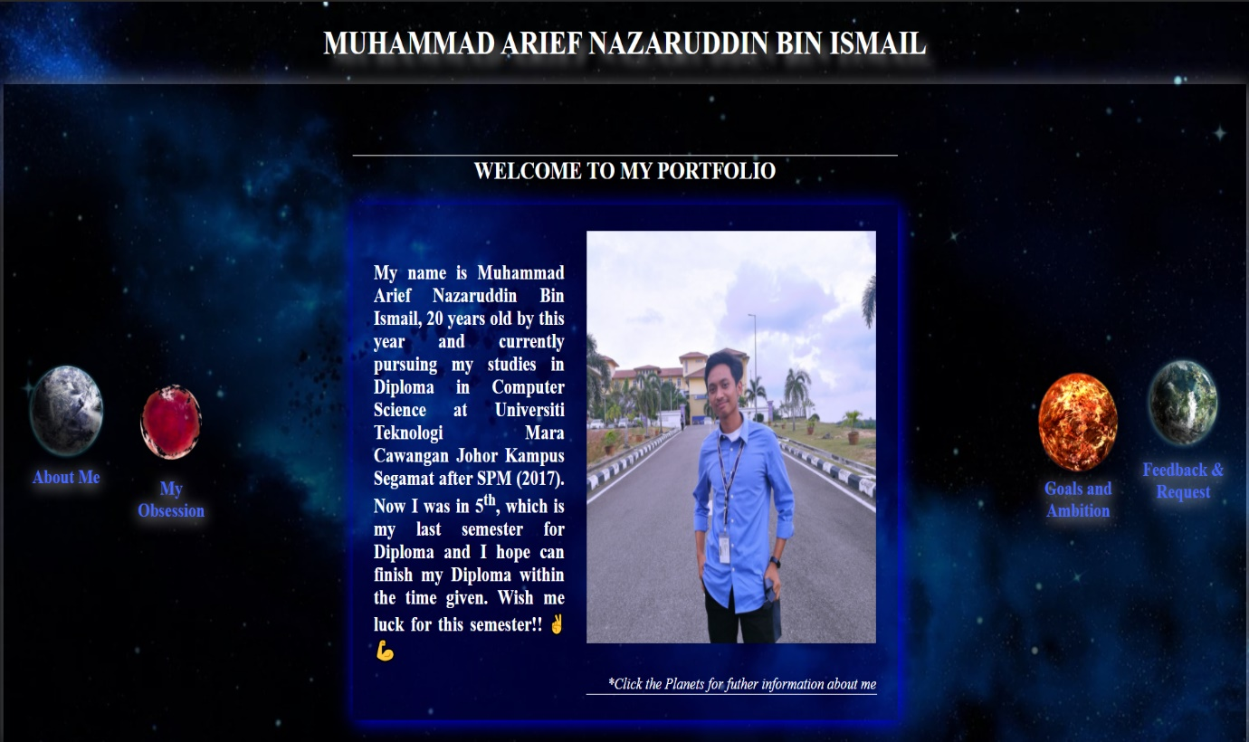

* Homepage contains my profile and link to another webpage

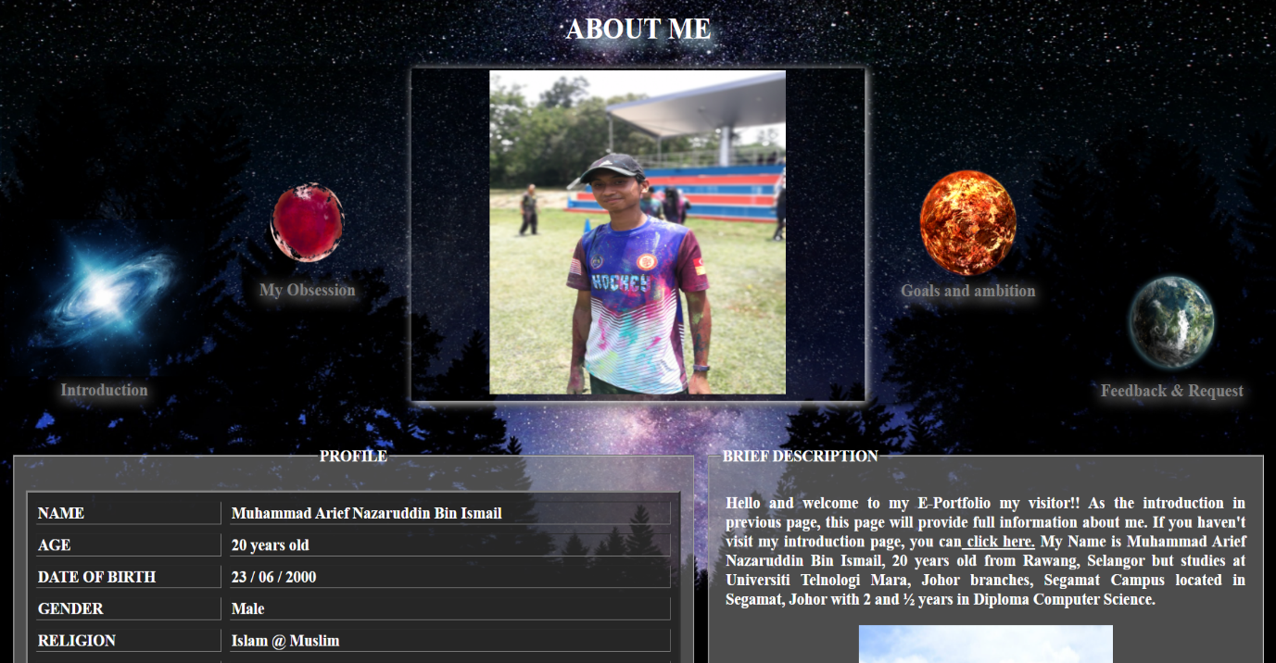

* About me page contain all my details and a brief description about me

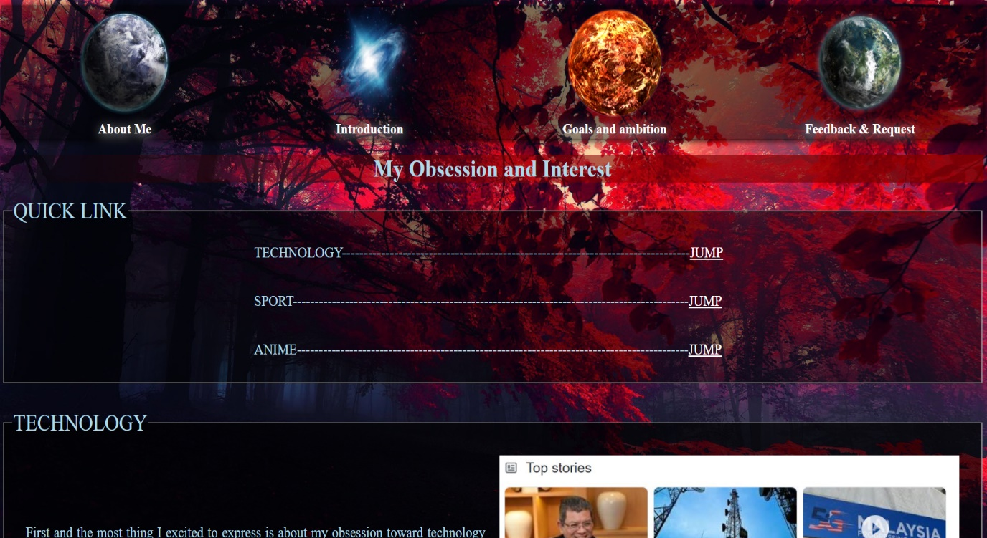

* 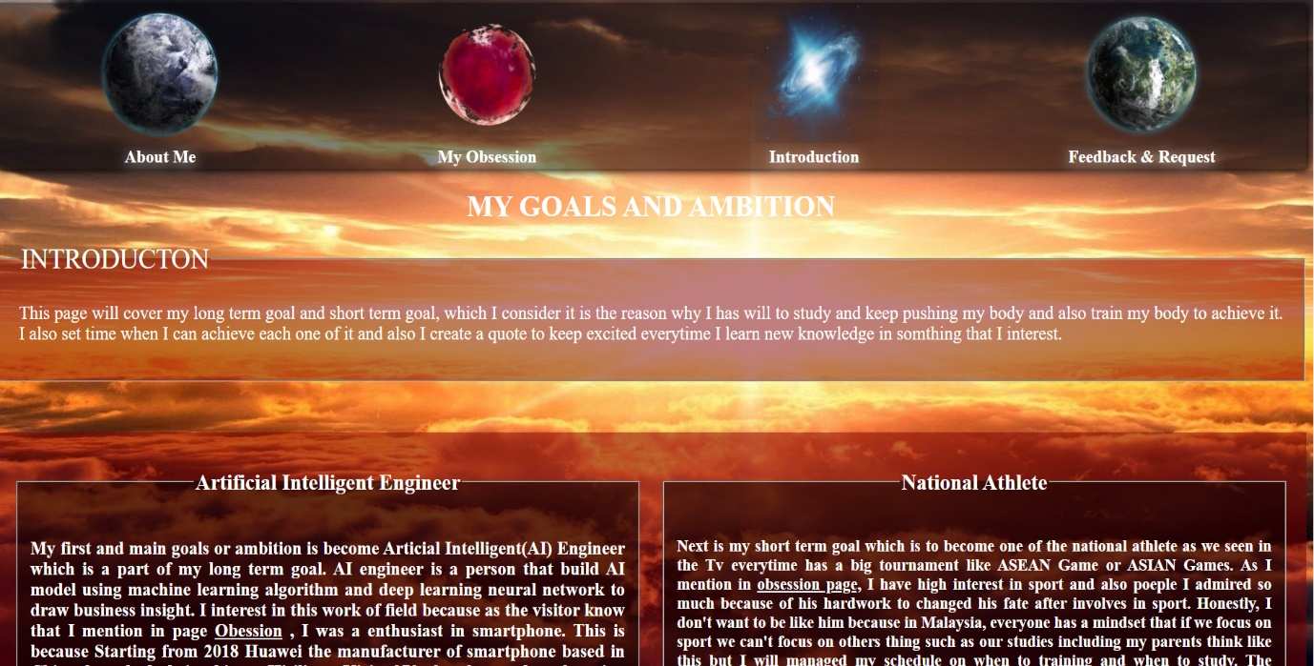The Obsession page containing all my obsession and some of my knowledge
* Goals and ambition that I divided into short term and long term

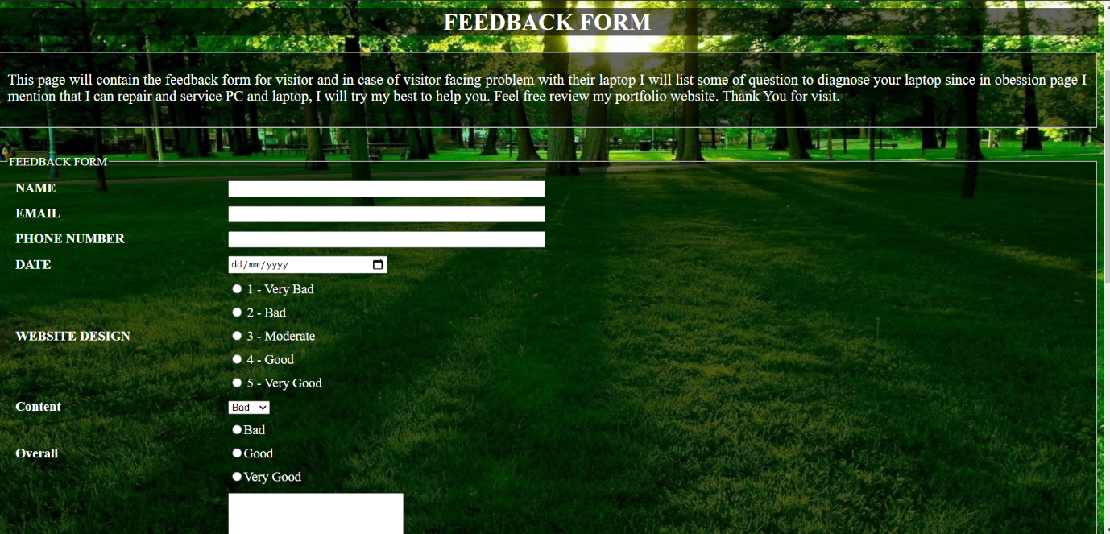

* Feedback page to visitor review all thing about my website and request form to diagnose laptop or Pc

REFERENCES

<https://www.w3schools.com/>

<https://www.payscale.com/research/MY/Skill=Artificial_Intelligence_(AI)/Salary>

<https://businessoverbroadway.com/2018/04/08/salaries-of-data-scientists-and-machine-learning-engineers-from-around-the-world/>

LINK

<https://e-portfolio-arief.000webhostapp.com/index.html>